Tawa Station Access Evidence Base

Executive Summary
This note is one of a series of notes that provide information and insights relating to access to stations in the Wellington Region to help stakeholders:

- understand current travel patterns
- identify opportunities for improving walking and cycling access to stations

Data is presented relating to:

- the number of people living within walking and cycling catchments of stations
- rail boarding and alighting numbers by time of day
- indicative rail capacity by time of day
- the mode used to access stations
- mode share of journey to work trips to Wellington CBD from within station catchments

The key insights from the Kapiti line analysis are as follows:

- Around 1.2 million rail boardings annually on the Tawa section of the Kapiti line
- Around 1,200 boardings in AM peak inbound, split across the 4 stations
- Volume / capacity ratios exceed 80% for most services upon departure from Takapu Rd
- Around 540 P&R spaces are split across Linden, Tawa and Takapu Rd stations
- Tawa station reaches capacity by 8:35am on weekdays
- Relatively few (3,500) people live within a 10-minute walk of a station and 10,000 people live within a 10-minute cycle of a station between Linden and Takapu Rd
- Some overlap between station catchments, particularly Takapu Rd and Redwood
- Around 60% of people access stations by foot and 40% by car
- Within the station walking catchments, the rail mode share of journeys to work in Wellington CBD is 70%, with the remainder (200 people) driving to the CBD
- Around 170 people live within 1 km walk of a station between Linden and Takapu Rd but drive to the station
- A direct bus service exists between Tawa and Wellington CBD but most people use this service to access Johnsonville; very few use it to access Wellington

The opportunities to encourage behaviour change and modal shift can be summarised as follows:

- around 40% of people access the rail station by car – this suggests there is scope to encourage people to consider other modes given the relatively small distances between suburbs and stations between Linden and Tawa
- around 170 people live within 1km walk of a station between Linden and Takapu Rd and drive to the station – this suggests there is opportunity to encourage people to walk / cycle to the station instead of driving
- around 200 people living within the rail walkup catchments – and more people within the wider Tawa basin catchment – drive to workplaces in Wellington CBD – there are opportunities to understand why people drive to work in the CBD to what could encourage them to use the train

- Purpose
This note is one in a series of notes summarising information relating to access to stations in the Wellington Region.
The following insights and data are provided:

- Population within specified distances and walking/cycling catchments of stations
- Station boardings and alighting by time of day
- Method of journey to work to Wellington CBD for people within walking/cycling catchments
- Observed access mode split by station and line
- Park and ride (P&R) capacity and occupancy
- Observed station catchments

The purpose of this evidence base is help stakeholders identify opportunities for improving walking and cycling access to stations and to encourage behaviour change.

- Kapiti line – patronage and capacity
  - Patronage
The annual patronage for the Kapiti Line (KPL) was 4.7 million for the year ending June 2021, with daily boardings of 16,900 (weekday). The Tawa section consists of 4 stations over 3 km of the Kapiti line. Patronage on this section accounts for approximately 23% of Kapiti Line boardings, equating to a daily average (weekday) of 3,800.
Table 1 below shows average daily boardings by time period and direction, for each stop, derived from the Automatic Train Counter (ATC) data.
Note the following:
- Whilst the ATC data is not 100% accurate, it has been verified against guard counts. The data should therefore be primarily used to provide an indication of patronage by time of day and to understand differences between stations along the line
- Outbound boardings from Wellington station have been estimated based upon outbound alightings at the relevant stations between Takapu Rd and Linden
- The time period definitions are as follows:
  - AM peak inbound boarding / alighting – people boarding / alighting from services that arrive into Wellington in the AM peak between 7am to 9am (i.e. they will be boarding services between approximately 6:40am and 8:40am)
  - AM peak outbound boarding – people boarding services from Wellington Station between 7am and 9am
  - Inter-peak – boardings and alightings between 11am and 1pm
  - Inter-peak outbound boarding – people boarding services that depart from Wellington between 11am and 1pm
  - PM peak outbound alighting – people who alight from services that departed Wellington between 4pm and 6pm
  - PM peak inbound boardings and alightings – people boarding / alighting from services departing between 4pm and 6pm.
Table 1 Daily inbound and outbound rail boardings by time of day, weekday and weekend
Figure 1 provides a graphical representation of the data summarised in Table 1
Figure 1: Daily weekday boardings, inbound & outbound, by time of day
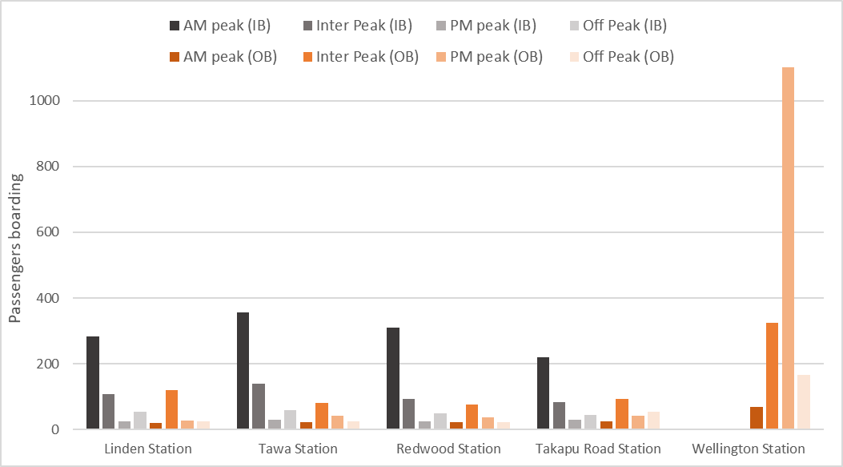
Table 2 below shows average daily (weekday and weekend) rail alightings by time period and direction, for each stop, derived from the ATC data.
As per the previous commentary, inbound alightings at Wellington Station are broadly assumed to be essentially equal to inbound boardings between Linden and Takapu Rd (the observed data shows small imbalances due to error margins in the train counters) (Figure 2 and Table 2).
Table 2: Daily alighting inbound & outbound by time of day, weekday & weekend
Figure 2: Daily alighting inbound & outbound
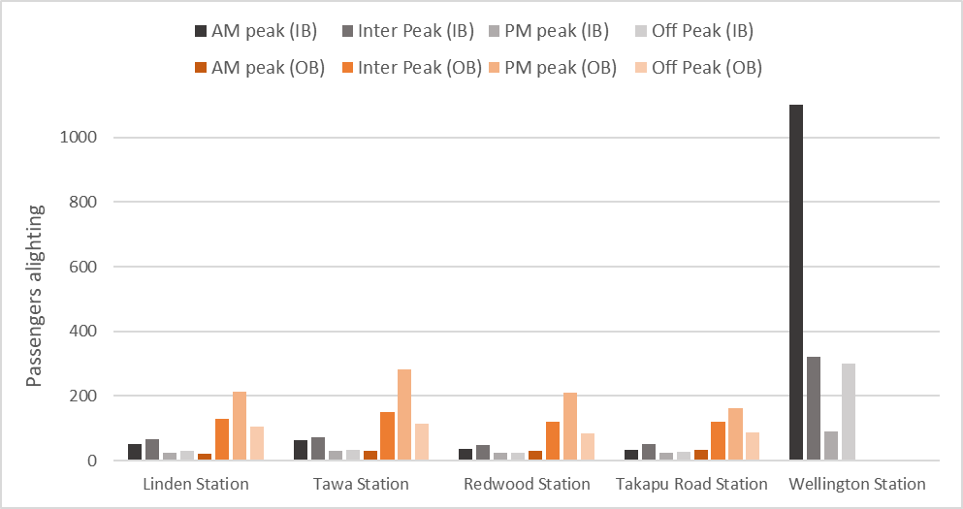
  - Volume/capacity ratio – crowding
Patronage data collected from the automatic train counters has been matched with capacity data (seated capacity) to estimate volume/capacity (V/C) ratios for services along the corridor and understand whether any crowding exists on the network.
Table 3 and Table 4 show the V/C ratio for inbound and outbound services by station of departure with the shading indicating the V/C ratio.
Note that the times relate to departure times from Linden (inbound) and departure times from Wellington (outbound).
Table 3: Volume/capacity ratio by inbound service by station
Table 4: Volume/capacity ratio by outbound service and station

The volume/capacity analysis shows:
- The highest passenger volumes and V/C ratios inbound occur during the morning peak between 7:00am–7:30am
- There is some crowding between 7:00am and 7:30am during the morning peak between Linden and Takapu Road

  - Park & ride capacity and utilisation
Table 5 shows park & ride (P&R) capacity matched against daily boarding at four stations on the Tawa section of the Kapiti line.
The table shows the following:
- Approximately 540 P&R spaces across 4 stations (one of which has no P&R)
- Across the AM peak, the ratio of P&R spaces to observed AM boarding is 46%
- Compared to other sections of the network, P&R accounts for a relatively high proportion of access trips to the rail station in the AM peak, possibly due to relatively small walk up catchments, no feeder bus services to the stations and freely available P&R capacity.
Table 5: Park & Ride Capacity, Tawa section of the Kapiti ine
Station | P&R capacity | AM rail boarding | Ratio | At 85% capacity
Linden Station | 0 | 281 | N/A | N/A
Tawa Station | 214 | 363 | 59% | 8:35am
Redwood Station | 147 | 306 | 48% | 7:55am
Takapu Road Station | 175 | 221 | 79% | Not reached
Total | 536 | 1171 | 46%

Figure 3 shows that of the three P&R facilities on the Tawa section of the Kapiti line, Redwood and Tawa are at 85% capacity by 7:55am and 8:35am respectively. Takapu Road has not reached 85% of capacity by 9am.
Figure 3: Regional park and ride facilities and the time when these are 85% occupied
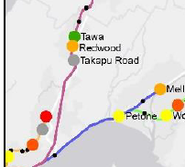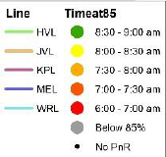

- Station walk and cycle catchments
The Tawa section of the Kapiti line starts at Takapu Road, 11.9 km from Wellington station, and finishes at Linden station, 3 km north.
The distance between stations are as follows:
- Takapu to Redwood 1.2 km
- Redwood to Tawa 0.7 km
- Tawa to Linden 1.1 km

The station catchment areas in this report are based on an average walking speed of 4 kph. Walking catchments to stops or stations are a general guide for distances people may be willing to walk to access public transport services:
- 5-minute walk or distance of up to 400 m
- 10-minute walk or distance of up to 800 m
Cycling catchments are also included, using an assumed cycle speed of 15kph and do not assume any terminal time (i.e. locking up/parking bike):
- 1 – 5 minute cycle or distance of 1.3 km
- 5 – 10 minute cycle or distance of 2.5 km
- 10 – 15 minute cycle or distance of 4 km

Cycling times in this analysis do not take into account relief (uphill and downhill), which is a significant factor in many parts of the Wellington Region.

  - Walking and cycling catchments
The methodology for estimating walking and cycling distance and time-based catchments was as follows:
- Obtain walking and cycling networks that include pedestrian walkways (in case of walking)
- Run GIS tool to create two types of catchments (distance and time) from each station for cycling and walking
- The assumed walking speed used was 4 kph and assumed cycling speed was 15 kph (note that neither speed accounts for terminal times).

The methodology was informed by discussions with WCC around a similar approach that they took to estimate broader catchments around PT stops. Whilst the WCC approach was more sophisticated, taking into account gradient and topography, applying the approach across the whole region, whilst robust, would require significant resources.
A pragmatic approach was taken, whereby the Kapiti line catchment analysis was undertaken as an example using both the WCC method and the simplified GWRC method to understand if there are any material differences between the methodologies.
The two methodologies were compared, this showed that on average 15% more people live within the GW 10-minute catchment compared to the WCC 10-minute catchment.
The different methodologies do not fundamentally change the relativities between different station catchments and, in our opinion, will not change any conclusions that might be drawn from this analysis.
Given the purpose of the station catchment analysis is to provide a high-level evidence base to inform more detailed work, the more simplified methodology is deemed appropriate for station catchment analysis.
Figure 4 shows the 5-minute and 10-minute walking catchments around each station for the Tawa section of the Kapiti line. Redwood and Tawa catchments overlap due to the short distance between these stations, this is 0.7 km by rail.

Figure 4: 5- and 10-minute walking catchment for Tawa stations
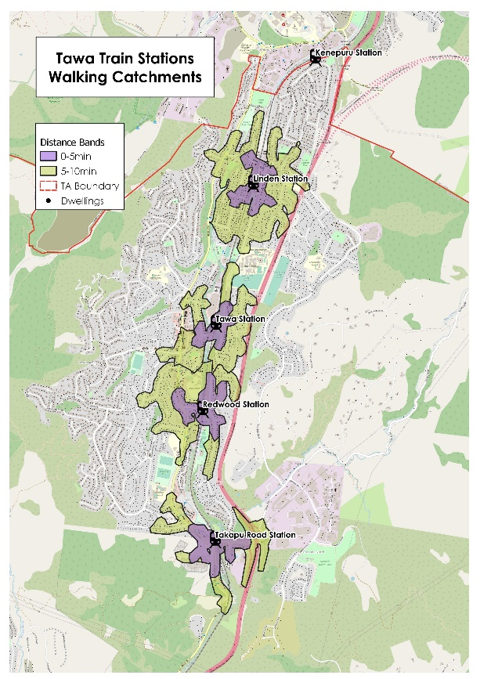

Station catchments based upon the following distance bands – up to 1 km, 1–2 km and 2–3 km are shown in Figure 5.

The cycle catchments are shown in Figure 6, up to 5- and 10-minute cycle (0 to 2.5 km). These catchments encompass most of the residential area surrounding the 4 stations.

Figure 5: Catchments for Tawa stations, by distance categories (left)
Figure 6: Cycle catchments for Tawa stations, by time categories (right)
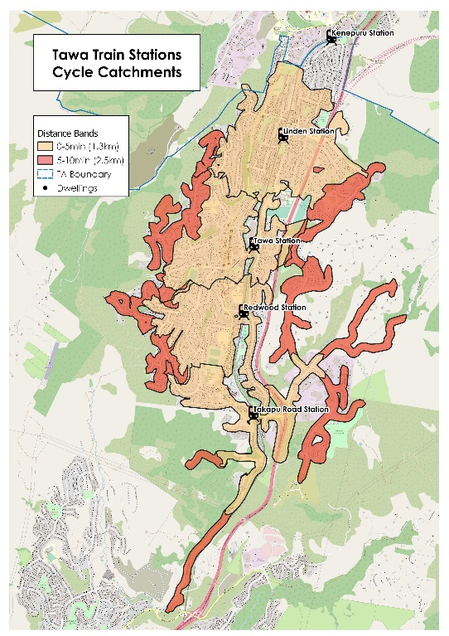
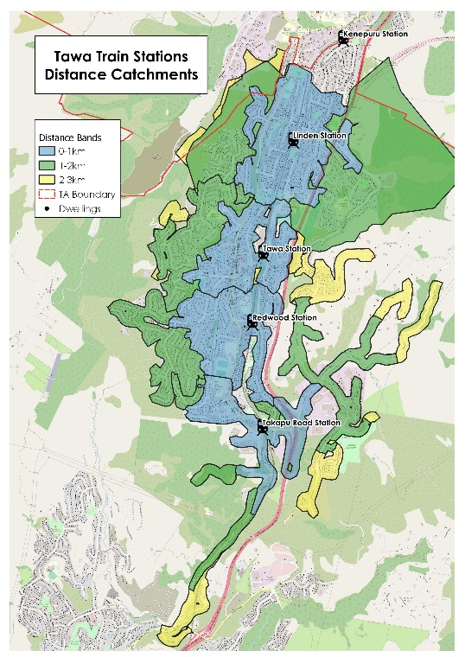

  - Residents within catchments
Having developed catchments for walking and cycling, the second step was to estimate the population within these catchments areas.
These figures were estimated using the following methodology:
- address points were sourced from Corelogic
- these were overlaid with the 2018 census data at a meshblock level
- the number of household address points in each meshblock was calculated, with the ‘average occupants’ per household calculated for each address point by dividing the total meshblock population by the number of address points within each meshblock.

This same approach was used to disaggregate other meshblock based variables, such as Census Journey to Work data by mode, to each address point.
Whilst it is accepted that this approach is approximate, for the purpose of this analysis and taking into account other variables and uncertainty the approach us considered appropriate.
Note that the catchment areas do not account for direction of travel – i.e. someone could be 0.5 km from their nearest station but required to walk in the opposite direction to their direction of travel to access the station, whereas there could be a station down the line (in their direction of travel) that might be technically farther away but more attractive. Therefore, the numbers relating to individual stations should to be taken as indicative, with the focus on relativities between different stations alongside the absolute numbers.
Table 6 shows the approximate residential population within different distance bands of stations on the Kapiti line within Tawa.
Table 6: Population within 3 km of a station on the KPL line
Station | Distance Bands |  |  | Total
Station | 0-1km | 1.01-2km | 2.01-3km | Total
Linden Station | 2722 | 1920 | 100 | 4,742
Tawa Station | 1412 | 1419 | 33 | 2,864
Redwood Station | 1897 | 1553 | 0 | 3,450
Takapu Road Station | 584 | 397 | 600 | 1,580
Total | 6,615 | 5,289 | 733 | 12,636

Table 6 shows Linden station has the largest population catchment within 3km and Takapu Rd the smallest. The Linden catchment doesn’t overlap with nearest stations Kenepuru and Tawa and is located in an area of relatively high housing density.
Table 7 shows that approximately 3,500 people live within a 5- to 10-minute walk (up to 800m) of their closest station. There are around 13,000 people within a 10-minute cycle (distance of 2.5 km) of a Tawa station on the Kapiti line (shown in Figure 5).

Table 7: Walking and cycling catchment by station
Station Name | Walk |  |  | Cycle
Station Name | 0-5 Min Walk | 5-10 Min Walk | Total | 0-5 Min Cycle | 5-10 Min Cycle | 10-15 Min Cycle | Total
Linden Station | 317 | 1,309 | 1,626 | 3,195 | 868 | 678 | 4,742
Tawa Station | 121 | 540 | 661 | 1,747 | 620 | 497 | 2,864
Redwood Station | 223 | 695 | 919 | 1,993 | 795 | 662 | 3,450
Takapu Rd Station | 43 | 263 | 306 | 481 | 550 | 589 | 1,620
Total | 704 | 2,807 | 3,512 | 7,416 | 2,832 | 2,428 | 12,676

Figure 7 below is taken from the 2017 rail survey report, showing the origin (home address) and station (by colour) accessed by the survey respondents. It clearly shows that there is some overlap between station catchments, especially Tawa station and Takapu Road.

Figure 7 Station catchment areas for rail survey
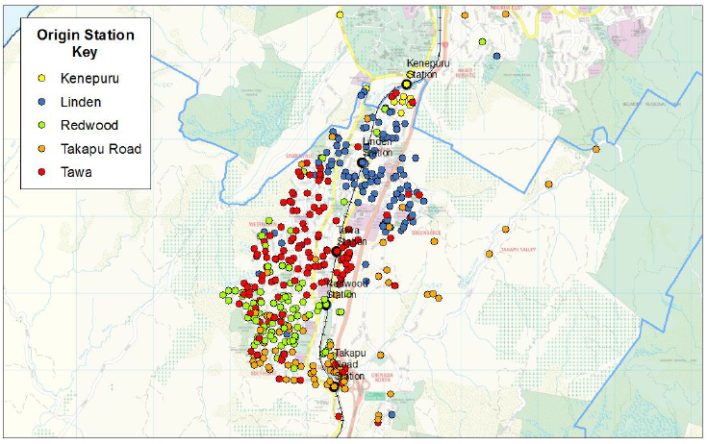
- Mode share by catchments – JTW data
Journey to work (JTW) data from the 2018 census for the Tawa catchment was analysed to identify commuting patterns and mode share. JTW data shows that 15% of trips are internal or within the Tawa area, 60% travel to Wellington CBD, 10% to Porirua, less than 5% to Lower Hutt and 10% to other areas in the region.
Journey to work mode share was calculated for walking catchment areas for those travelling to Wellington CBD, using address point data with JTW data at a meshblock level.
The data, shown in Table 8, refers to commuters within a 10-minute walk of their nearest station.
The commuter catchment analysis shows the following:
- Rail mode share is similar across all station catchments, from 65%–71%
- Around 30% of people (n=200) live within a 10-minute walk of a rail station and drive to destinations in Wellington CBD
- Linden station has the highest catchment population due in part to no overlap with other station walking catchments and higher housing density. There is no park and ride but free on-street parking.
Table 8: Mode share for commute to Wellington CBD – people within 10 minute walking catchment
Stations | Car | Rail | bus | walk/  cycle | Total | Car % | Rail % | bus % | walk/  cycle % | Total
Linden Station | 90 | 189 | 0 | 0 | 279 | 32% | 68% | 0% | 0% | 100%
Tawa Station | 40 | 99 | 0 | 0 | 139 | 29% | 71% | 0% | 0% | 100%
Redwood Station | 52 | 124 | 0 | 0 | 176 | 29% | 71% | 0% | 0% | 100%
Takapu Road Station | 30 | 58 | 0 | 1 | 89 | 34% | 65% | 0% | 1% | 100%
Total | 212 | 471 | 0 | 1 | 684 | 31% | 69% | 0% | 0% | 100%

Travel to the Wellington CBD from the Tawa catchment is illustrated in Figure 8.
At an SA2 level, public transport mode share ranges from 50% – 70% for work trips into the Wellington CBD, with the high PT mode share a function of the fast and frequent rail services along the corridor.
Points to note:
- Grenada North has highest car usage for travel to the Wellington CBD, probably a function of it not being on the rail corridor, being at the end of the bus line and having good access to SH1
- Churton Park North, which is not in the Tawa catchment area (but on the southern boundary) has bus mode share of about 25% to the Wellington CBD but has the highest car mode share to Wellington CBD in the whole of Wellington region at around 75%.
Figure 8: Mode share for JTW to Wellington CBD
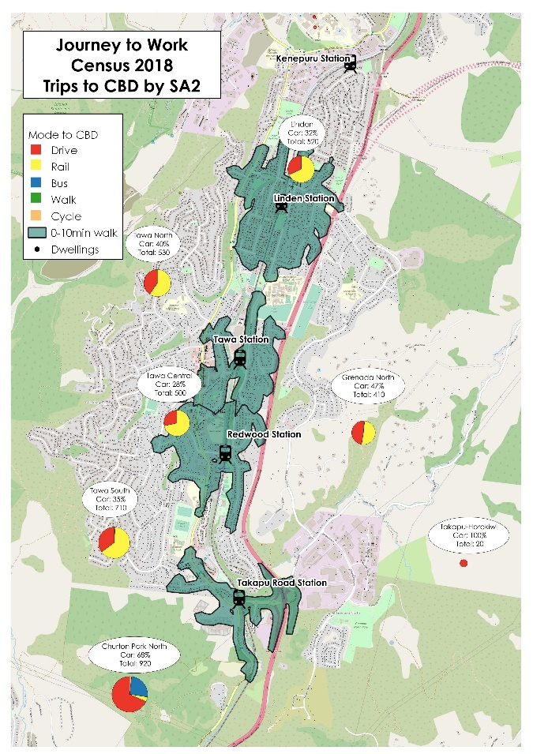

- Access to the station
How people access the train was estimated using the 2017 Rail survey expansion data (GWRC) and older 2011 rail survey.
Table 9 shows the mode share for access to the station from the 2017 rail survey, which then applied to the daily inbound weekday boardings (November 2020) to estimate numbers accessing each of the four stations by transport access mode.
The survey found rail passengers accessing the Tawa section of the Kapiti line used either motor vehicles (40%) or travelled on foot (59%). There were significant access differences between stations; a greater proportion of passengers at Linden station walked to the station (80%) compared to Tawa passengers (47%).
Table 9: Access to station, inbound weekday

The 2017 Rail Survey analysis looked at mode used to access stations by distance (from home address), as shown in Figure 9. The figure shows access for all survey participants on the whole Kapiti line.
Figure 9: Mode used to access the station by distance to station (Kapiti line)
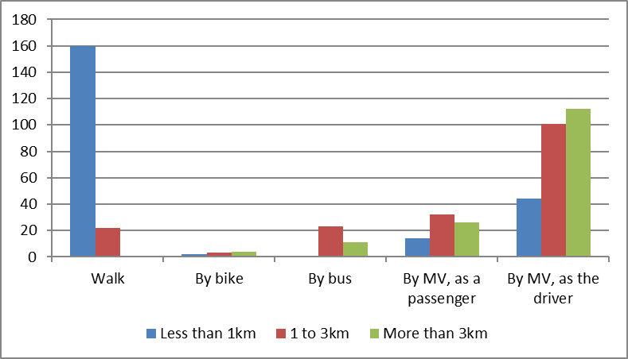

Based on the survey results, the number of people cycling to the station is low. Cycle facilities at stations in the Tawa area are minimal, with cycle racks provided at Redwood station only.
By combining estimates of how rail users access the station with daily boardings we have estimated the number of people accessing the station by car who live within the 1 km catchment, see Table 11.
The analysis found that, on average, 14% of those using a motor vehicle to access the Tawa section of the Kapiti line were living less than 1 km or within a 10 min walk from a station, showing there is some opportunity to influence behaviour and encourage modal shift from car to walk/cycle access to rail stations in this area.
Table 11: Rail passengers within 1km catchment who access the station by car

The main findings from this analysis are as follows:

- Linden station has a high walk access mode share
- 40% of people drive to a Tawa station during the morning peak
- An estimated 14% (150) of rail passengers living in the 1km walk catchment drive to station, suggesting there is an opportunity to change behaviour toward active travel for those accessing station within 1km walking catchment

Figure 10 shows the home location and access mode to the station for survey participants. Of note is the overlap between car and walk access catchments, suggesting that access mode choice is a function of both distance and personal preference.

Figure 10: 2017 Rail survey access to station – Tawa section of KPL
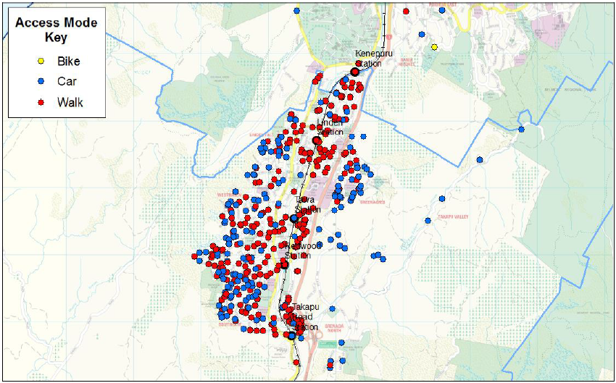
- Bus boardings
Bus boarding and alighting data is sourced from ETM data (Metlink). It has been used as follows:
- to understand the number of boardings and alightings relating to trips to/from the CBD that occur within the 10-minute walking catchments of stations, to understand the level of overlap between bus and rail catchments
- to estimate transfers from bus to rail (and vice versa) using a combination of ETM data and survey data.
In Tawa, passenger boardings for services to the Wellington CBD are very low at around 70 boardings per week. The usage of Monthly plus tickets is also very low in Tawa, indicating that bus to train transfers are not common in this area, which is largely a function of the rail network in Tawa having no feeder bus services.

Bus commuters are broadly split between those heading to Wellington and Porirua (Figure 10, Table 1 and Figure 11). The numbers of bus boardings are low compared with the number of rail boardings.

Figure 10: Monthly Bus boardings by Destination (all day)
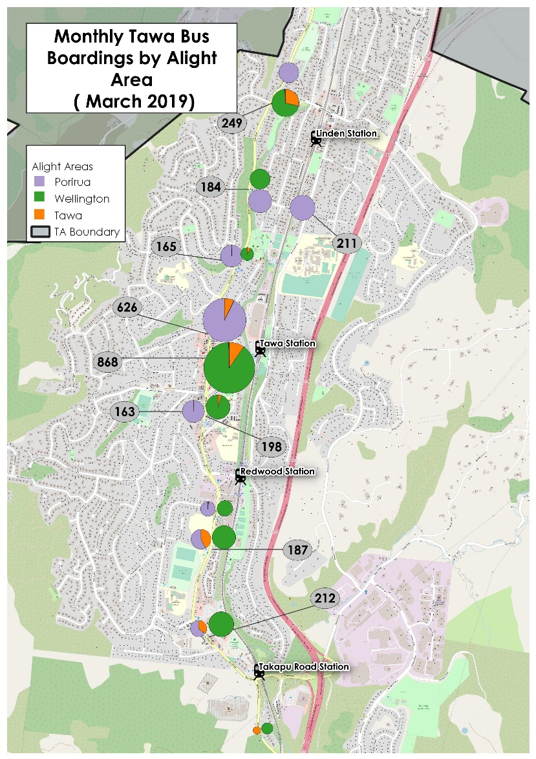

Table 10: Monthly bus boardings by hour and destination
Hour of Day | Destination (monthly total)
Hour of Day | Porirua | Wellington | Tawa | Grand Total
06:00 | 7 | 154 | 1 | 162
07:00 | 174 | 371 | 5 | 550
08:00 | 247 | 216 | 27 | 490
09:00 | 171 | 178 | 40 | 389
10:00 | 152 | 134 | 40 | 326
11:00 | 144 | 115 | 25 | 284
12:00 | 135 | 91 | 26 | 252
13:00 | 87 | 83 | 24 | 194
14:00 | 54 | 164 | 32 | 250
15:00 | 344 | 134 | 35 | 513
16:00 | 50 | 67 | 14 | 131
17:00 | 55 | 100 | 26 | 181
18:00 | 29 | 23 | 6 | 58
19:00 | 6 | 13 | 3 | 22
20:00 | 1 | 17 | 4 | 22
21:00 | 1 | 4 | 0 | 5
Total | 1,657 | 1,864 | 308 | 3,829

Figure 11: Chart of monthly bus boarding by hour and destination
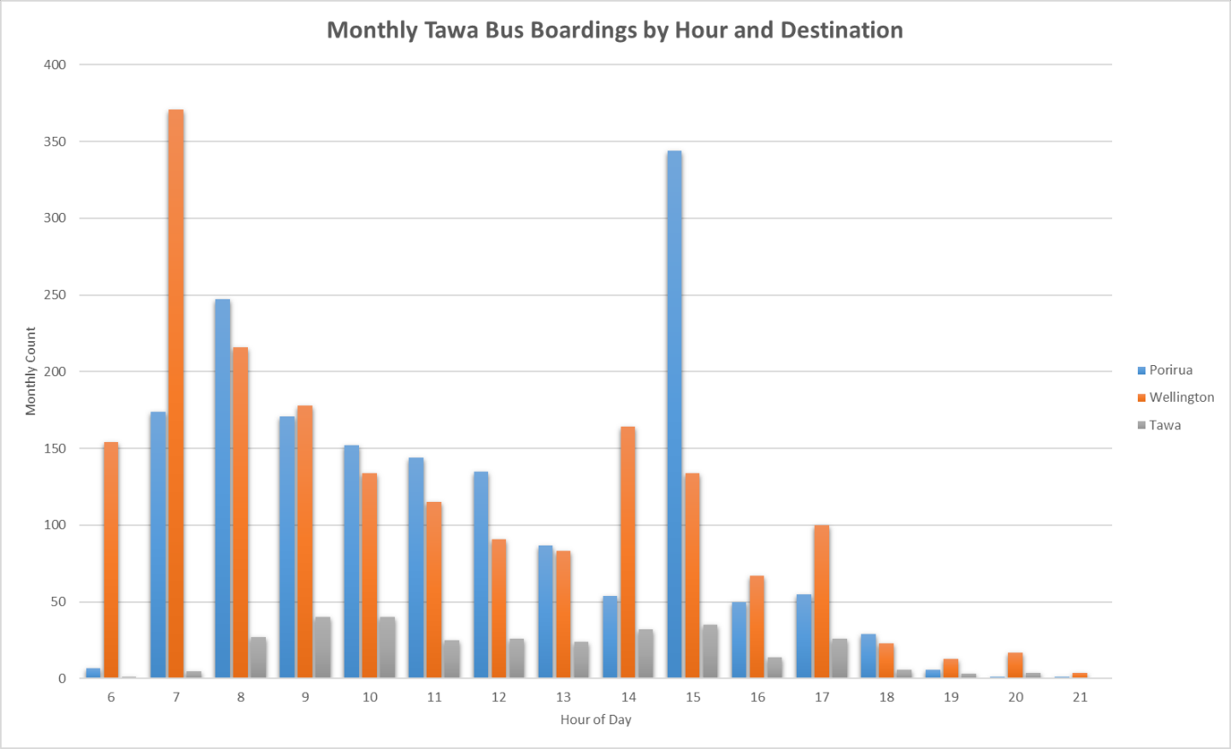

Note this is 21% down on pre-Covid boarding
A statistical area 2 (SA2) is a geographical area defined by Statistics New Zealand. SA2s typically have a population of about 3000 people.
Rail Survey 2017: Park & Ride Data Note, GWRC; page 14. This analysis was based on the survey data, so any estimates should be treated with caution. As well, patrons who drove did not always access their closest station.

