Johnsonville Line Station Access Evidence Base

Executive Summary
This note covers stations between Crofton Downs and Johnsonville and is one of a series of notes that provide information and insights relating to access to stations in the Wellington Region to help stakeholders:

- understand current travel patterns
- identify opportunities for improving walking and cycling access to stations

Data is presented relating to:

- the number of people living within walking and cycling catchments of stations
- rail boarding and alighting numbers by time of day
- indicative rail capacity by time of day
- the mode used to access stations
- mode share of journey to work trips to Wellington CBD from within station catchments

The key insights from the Johnsonville line analysis are as follows:

- over 1.1m annual boardings
- around 1200 boardings in AM peak inbound, split evenly between stations
- significant outbound AM peak and inbound Inter-peak school demand from Raroa
- no capacity issues at peak times
- 9,500 people live within a 10 min walk of a station and 40,000 people within a 10 min cycle of a station on the Johnsonville line
- a significant overlap between observed station catchments, due to the close spacing of stations
- around 80% of people walk to access the station, with 20% driving
- within the Johnsonville Station walking catchment, the rail mode share of PT trips to Wellington CBD is 25%, highlighting the attractiveness of bus services from this area to the Wellington CBD
- elsewhere along the Johnsonville line, the rail mode share of PT trips to Wellington CBD in the AM peak is around 70%

The opportunities to encourage behaviour change and modal shift can be summarised as follows:

- over 50% of people living within a 10-minute walk of stations on the Johnsonville line who work in Wellington CBD travel to work by car – opportunity to achieve modal shift from car to rail
- around 150 people live within 1km (a 10-minute walk) of their boarding station and drive to station – opportunity to change access mode from car to walking / cycling

- Purpose
This note is the first in a series of notes summarising information relating to access to stations in the Wellington Region.

The following insights and data are provided:
- Population within specified distances and walking / cycling catchments of stations
- Station boardings / alighting by time of day
- Method of journey to work to Wellington CBD for people within walking / cycling catchments
- Observed access mode split by station and line
- Park and Ride (P&R) capacity and occupancy
- Observed station catchments

The purpose of this evidence base is help stakeholders identify opportunities for improving walking and cycling access to stations and to encourage behaviour change.

- Johnsonville line – patronage and capacity
  - Patronage
The annual patronage for the Johnsonville line was 1.16 million in 2021 (year ending June), approximately 10% of annual regional rail boardings. Average daily boardings AM peak time (7am to 9am) were 1,200.

Johnsonville rail boarding and alighting data from November 2020 was used to understand patronage profiles by station, time of day and direction.
- The time period definitions are as follows:
  - AM peak inbound boarding / alighting – people boarding / alighting from services that arrive into Wellington in the AM peak between 7am to 9am (i.e. they will be boarding services between approximately 6.40am and 8.40am)
  - AM peak outbound boarding – people boarding services from Wellington Station between 7am and 9am
  - Inter-peak – boardings and alightings between 11am and 1pm
  - PM peak outbound boarding – people boarding services that depart from Wellington between 11am and 1pm
  - PM peak outbound alighting – people who alight from services that departed Wellington between 4pm and 6pm
  - PM peak inbound boardings and alightings – people boarding / alighting from services departing between 4pm and 6pm.
Table 1 below shows average daily boardings (weekday and weekend separately) by time period and direction, for each stop, derived from the Automatic Train Counter data (ATC). Note that whilst the ATC data is not 100% accurate, the data has been verified against guard counts and provides a good indication of different trends between different stations.
Table 1: Daily boarding inbound and outbound by time of day, weekday and weekend
Figure 1 provides a graphical representation of the data summarised in Table 1
Figure 1: Daily weekday boardings inbound & outbound by time of day
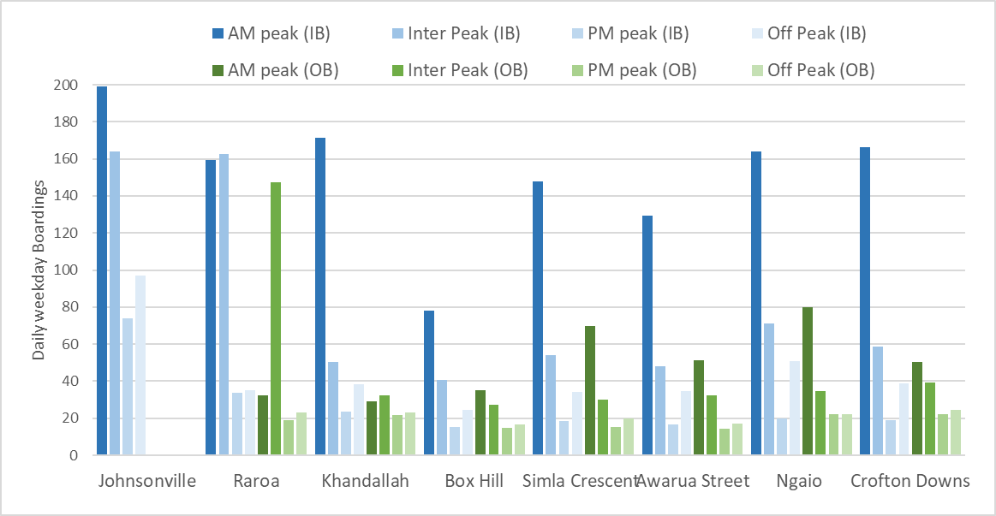
Boarding are high at both AM peak and interpeak for Johnsonville and Raroa station. Inter-peak boardings at Raroa station are high (IB and OB) compared to other stops due to student travel (both secondary & intermediate schools nearby).
Table 2 below shows average daily alightings (weekday and weekend separately) by time period and direction, for each stop, derived from the Automatic Train Counter data.

Table 2: Daily alighting inbound & outbound by time of day, weekday & weekend
Figure 2 is a graphical representation of the data in Table 2. The figure shows Raroa station has a different commuter pattern to the other stations with majority of alighting outbound occurring during AM peak compared to the PM peak for other stations on the Johnsonville line.
Figure 2: Daily alighting inbound & outbound
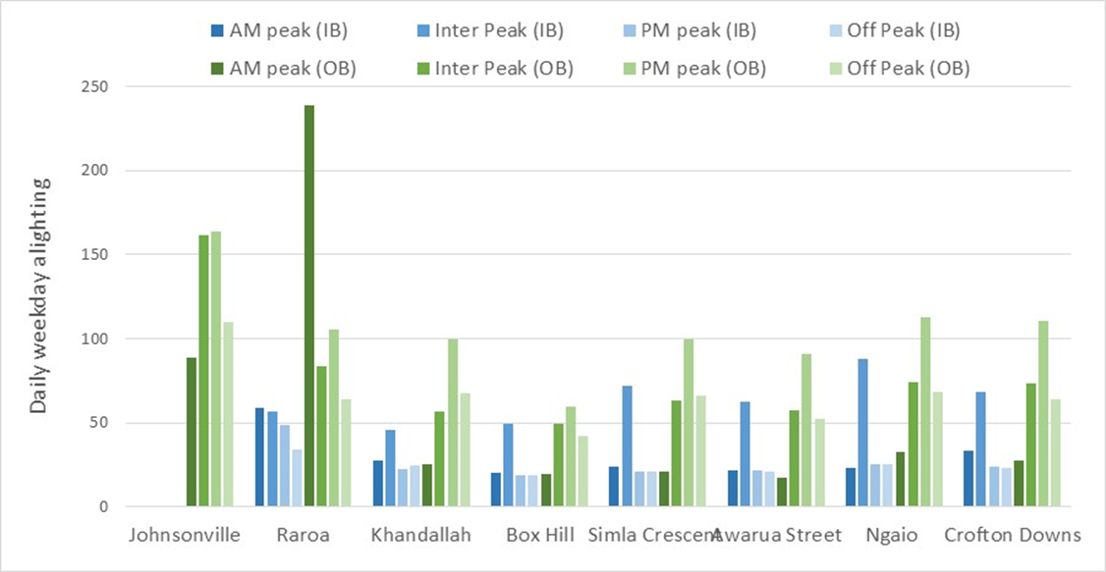
The high morning peak alighting numbers at Raroa is due to students travelling to college and intermediate schools.
  - Volume/capacity ratio – crowding
Patronage data collected from the automatic train counters has been matched with capacity data (seated capacity) to estimate volume/capacity (V/C) ratios for services along the corridor and understand whether any crowding exists on the network.
Table 3 and 4 show the V/C ratio for inbound and outbound services by time and station with the shading indicating the level of crowding based on the V/C ratio.
Table 3: V/C ratio for inbound morning services by station
Table 4: V/C ratio for outbound afternoon services by station
The volume/capacity analysis shows:
- The highest passenger volumes and V/C ratios (67%) occur inbound during the morning peak between 7.30am and 8am
- In general there are no crowding issues on the Johnsonville line – there is sufficient capacity at all times of the day to cater for current and any potential future increase in demand

  - Park & Ride capacity and utilisation
There are approximately 200 park and ride (P&R) spaces at stations along the Johnsonville line, with five out of eight stations having P&R spaces.
A study undertaken in 2018 determined that P&R spaces were at 85% occupancy rate before 8:00am for three of the five P&R locations. (Source: MRCagney Park & Ride Study 2018).
Table 5 shows P&R capacity with daily boarding at each station on the Johnsonville line. Overall, around 10% of peak period passengers R&R – this is a low percentage (relative to the rest of the network), largely a function of the close walk-up catchment of the Johnsonville line, close stop spacing and a low quantity of P&R spaces for commuters.
Table 5: Park & Ride capacity, Johnsonville line
Data source: MR Cagney Park & ride study
Figure 3: Regional Park and Ride facilities and time when these are 85% occupied
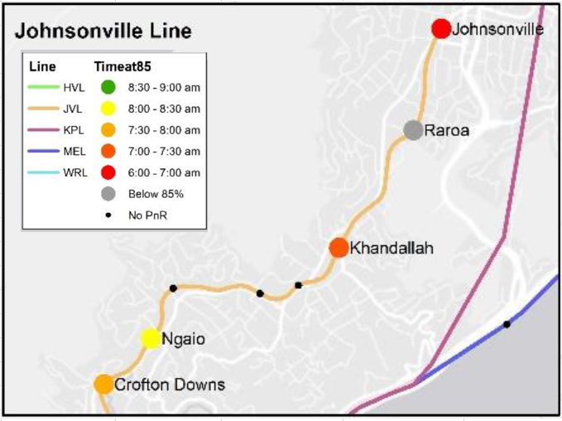

- Station walk and cycle catchments
The Johnsonville line runs from Wellington station north to Johnsonville (9km) via Ngaio and Khandallah. There are 8 stations within 5.6 km between Crofton Downs and Johnsonville, with the distances between stations as follows:

- Crofton Downs to Ngaio – 0.7 km
- Ngaio to Awarua Street – 0.6 km
- Awarua Street to Simla Crescent – 0.8 km
- Simla Crescent to Box Hill – 0.4 km
- Box Hill to Khandallah – 0.6 km
- Khandallah to Raroa – 1.5 km
- Raroa to Johnsonville – 1.0 km
The station catchment areas in this report are based on an average walking speed of 4 kph. Walking catchments to stops or stations are a general guide for distances people may be willing to walk to access public transport services:
- 5-minute walk or distance of up to 400 m
- 10-minute walk or distance of up to 800 m
Cycling catchments are also included, using an assumed cycle speed of 15 kph and do not assume any terminal time (i.e. locking up/parking bike):
- 0 – 5 minute cycle or distance up to 1.3 km
- 5 – 10 minute cycle or distance up to 2.5 km
- 10 – 15 minute cycle or distance up to 4 km

Cycling times in this analysis do not take into account relief (uphill and downhill), which is a significant factor in many parts of the Wellington Region.

  - Walking and cycling catchments

The methodology for estimating walking and cycling distance and time based catchments, to be used to estimate the number of people within these catchments, was as follows:

- Obtain walking and cycling networks that include pedestrian walkways (in case of walking)
- Run GIS tool to create two types of catchments (distance and time) from each station for walking and cycling
- The assumed walking speed used was 4 kph and assumed cycling speed was 15 kph (note that neither accounts for terminal times)

The methodology was informed by discussions with WCC around a similar approach that WCC took to estimate broader catchments around PT stops.

The WCC approach was more sophisticated and detailed as it included the following:
- traffic signals/crossing points to influence walking times (delays at intersections)
- DEM (digital elevation models) to use slope gradient
- Trips were grouped depending on whether travel was towards or leaving the station (that is, people generally walk faster downhill than uphill, so depending on the direction of travel, the catchment size changes depending on the gradient)
- used various sources to define walking speed such as literature, Strava (fitness tracker) and internal data collection
- a more comprehensive and bespoke network of links specific to the WCC network was not available (or would be time consuming to create) for GWRC to use for a regional analysis

Applying the WCC approach across the whole region would provide a robust and consistent methodology but would also require more time, effort and resources.

A pragmatic approach was taken, whereby the Johnsonville line catchment analysis was undertaken using both the WCC method and the simplified GWRC method to understand if there are any material differences between the methodologies.

Table 6 below compares walking catchment populations using both WCC and GW methods. Comparing the results in the 10 minute catchment, on average 15% more people live within the GW catchment compared to the WCC catchment.
The different methodologies do not fundamentally change the relativities between different station catchments and, in our opinion, will not change any conclusions that might be drawn from this analysis.
Given the purpose of the station catchment analysis is to provide a high level evidence base to inform more detailed work, the more simplified methodology is deemed appropriate.

Table 6: Walking catchment populations using WCC and GWRC methodologies
Station | WCC |  |  | GW |  |  | Total  difference (GW–WCC)
Station | 0-5 min | 5-10 min | Total | 0-5 min | 5-10 min | Total | Total  difference (GW–WCC)
Johnsonville Station | 260 | 1010 | 1270 | 312 | 1171 | 1483 | 14%
Raroa Station | 64 | 361 | 425 | 88 | 551 | 639 | 33%
Khandallah Station | 180 | 288 | 468 | 174 | 449 | 623 | 25%
Box Hill Station | 150 | 313 | 463 | 161 | 231 | 392 | -18%
Simla Crescent Station | 155 | 254 | 409 | 165 | 334 | 499 | 18%
Awarua Street Station | 113 | 376 | 489 | 151 | 445 | 596 | 18%
Ngaio Station | 140 | 289 | 429 | 108 | 385 | 493 | 13%
Crofton Downs Station | 120 | 210 | 330 | 106 | 209 | 315 | -5%
Total | 1182 | 3101 | 4283 | 1265 | 3775 | 5040 | 15%

Figure 3.1: WCC average combined walking catchment to/from station (left)
Figure 3.2: GW walking catchment (right)
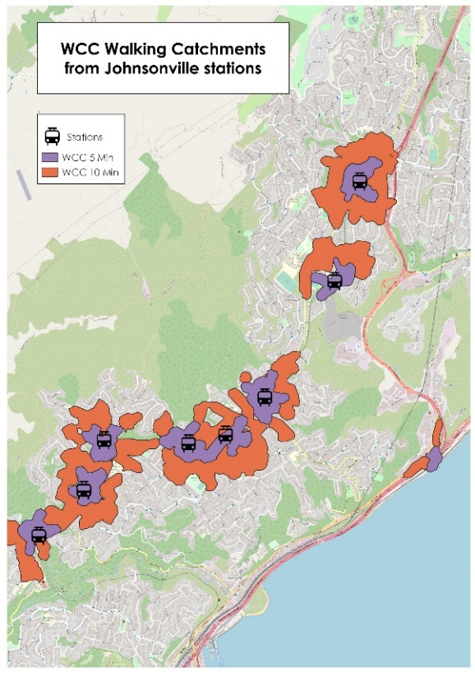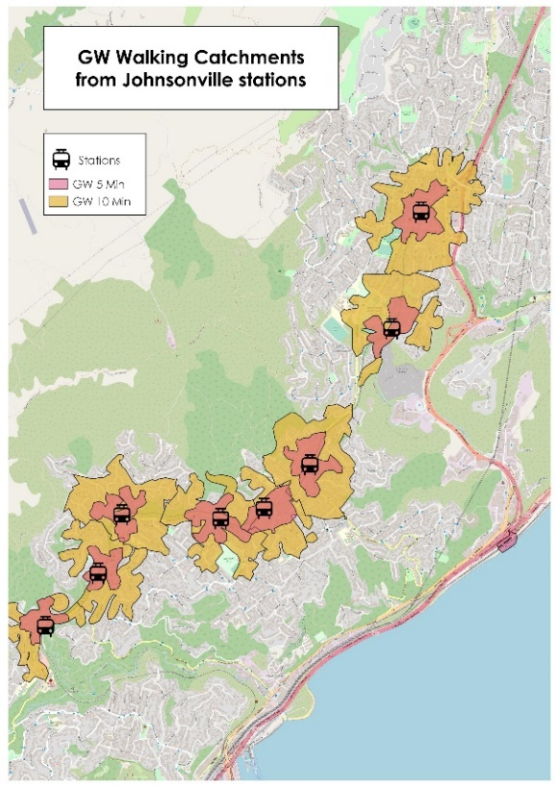

Figure 4: Station catchment for Johnsonville line by distance categories (left)
Figure 5: Station Cycling catchment for Johnsonville line by time categories (right)
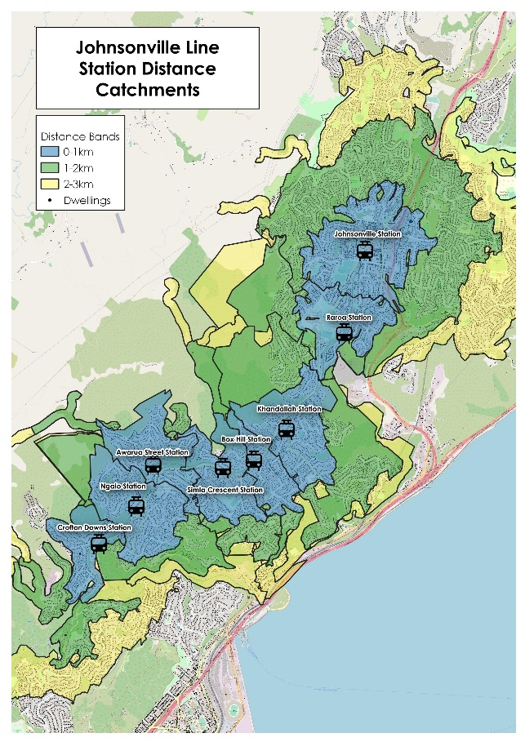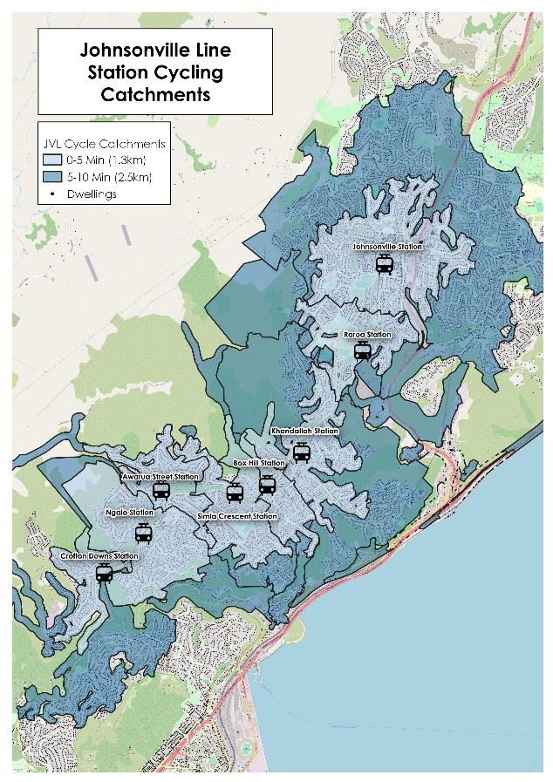
  - Residents within catchments
Having developed catchments for walking and cycling, the second step was to estimate the population within these catchments.

These figures were estimated using the following methodology:
- address points were sourced from Corelogic
- address point were overlaid with the 2018 census data at a meshblock level
- the number of household address points in each meshblock was calculated, with the ‘average occupants’ per household calculated for each address point by dividing the meshblock population by the number of address points within each meshblock.

This same approach was used to disaggregate other meshblock based variables, such as census journey to work data by mode, to each address point.

Whilst it is accepted that this approach is approximate, for the purpose of this analysis and taking into account other variables and uncertainty the approach us considered appropriate.

Table 7 shows the approximate residential population within different distance bands of stations on the Johnsonville Line.
Note that the catchment areas do not account for direction of travel – i.e. someone could be 0.5 km from their nearest station but required to walk in the opposite direction to their direction of travel to access the station, whereas there could be a station down the line (in their direction of travel) that might be technically farther away but more attractive.
Therefore, the numbers relating to individual stations should be taken as indicative, with the focus on relativities between different stations alongside the absolute numbers.
A greater level of confidence should be applied to the analysis pertaining to the whole catchment as opposed to the station specific analysis, particularly for the Johnsonville line where stations are closely spaced and there would be significant overlap in terms of catchments.

Table 7: Population within 3 km of a station on the Johnsonville line
Table 8: Walking and cycling catchment by station
Table 8 shows that approximately 9,500 people live within a 10-minute walk (up to 800 m) to their closest station.
Approximately 40,000 people live within a 10-minute cycle (up to 2.5 km) from a station on the Johnsonville line (shown in Figure 5).
Figure 5 below is taken from the 2011 rail survey and shows the station used by survey respondents. It clearly shows that there is some overlap between station catchments, particularly around Simla Crescent and Awarua Street.
Figure 6 Station catchment areas
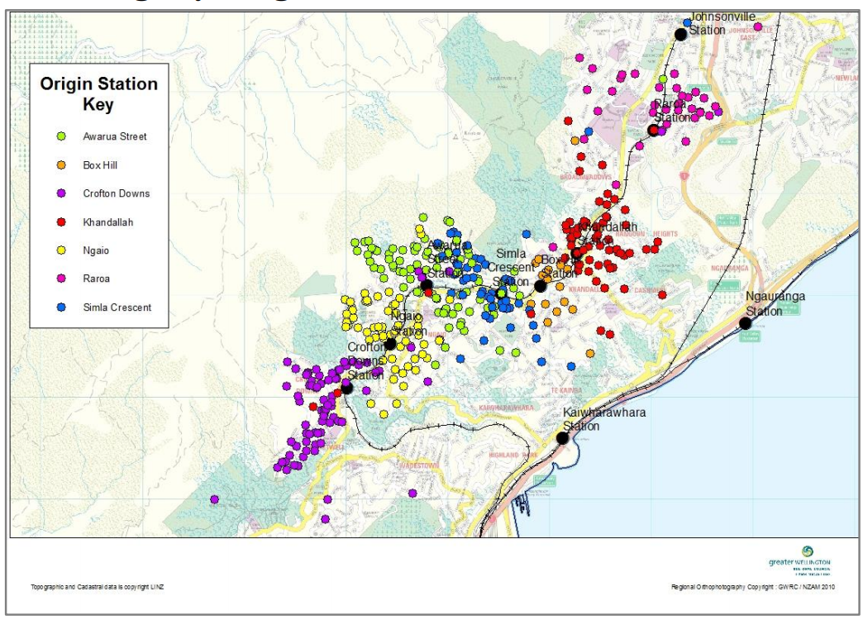

- Mode share by catchments – journey to work data
Journey to work (JTW) data from the 2018 census for the Johnsonville line catchment was analysed to identify commuting patterns and mode share. The JTW data shows 70% of commuters who reside in Wellington northern suburbs travel to the Wellington CBD for work, 11% travel to destinations elsewhere in Wellington City and 19% travel to Porirua or Hutt Valley.
Journey to work mode share was calculated for walking catchment areas for those travelling to Wellington CBD, using address point data to JTW data to a meshblock level.
The data, shown in Table 9, refers to commuters within a 10-minute walk catchment of each station.
The analysis shows the following:
- Rail mode share was highest at Awarua Street and Crofton Downs
- Bus mode share into the CBD was highest in the Johnsonville catchment (31%), a result of Metlink Route 1 – a core service – providing a competitive travel time compared to taking the train and transporting people further into the CBD than the train
- Car mode share of JTW trips is between 40% and 55% across all stations, suggesting that there is a significant opportunity across the whole catchment area to change behaviour and encourage some of these car commuters to take the train
- The opportunity to change behaviour and encourage more people to take the train is greater for station catchments other than Johnsonville, where bus is currently a more attractive option for commuting compared to the train

Table 9: Mode share for commute to Wellington CBD – people within 10-minute walking catchment of station
Mode share to the CBD is also illustrated in Figure 7 showing at a statistical area 2 (SA2) level people travelling to work by public transport and by car (either alone or with others).
Public transport mode share is on average 47% for walking catchments. The highest rail mode share at 40% in Awarua catchment and highest bus mode share (31%) in Johnsonville catchment. From north to south there is a slight trend for rail mode share to increase and bus mode share decrease in the southern catchments (except Ngaio).
Figure 7: Modeshare for JTW to Wellington CBD
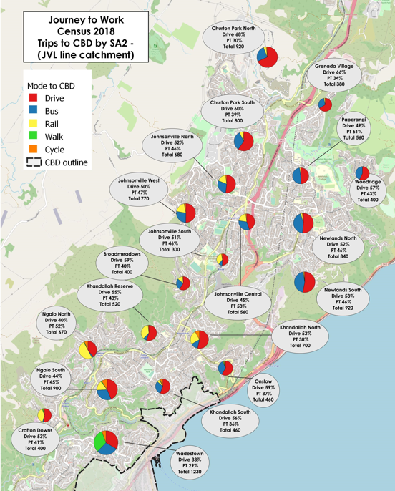

- Access to the station
How people access the train was estimated using the 2017 Rail survey expansion data (GWRC) and older 2011 rail survey.
Both surveys – particularly the 2011 survey – have relatively low sample size for the Johnsonville line which, combined with the low levels of patronage, can result in some ‘lumpiness’ when expanding data to match observed counts.
Therefore the figures relating to cycling in particularly should be treated with caution.
Table 10 shows the mode share for access to the station from the 2017 rail survey and this is applied to the daily boardings, inbound weekday (2020) to estimate current volume of private vehicle use.
The majority of rail passengers access the Johnsonville line on foot (78%); the average car mode share is 22%, with Raroa (48%) the highest followed by Ngaio (37%). The higher car use for Raroa and Ngaio stations is likely due to the availability of P&R spaces, combined with informal P&R opportunities close to both stations.
Table 10: Access to station, inbound weekday
MV = motor vehicle.

The 2017 Rail Survey analysis looked at mode used to access stations by distance, as shown in Figure 8. This shows access to the station by all survey participants across the regional rail network. The number of people cycling to the station is low, possibly due to hilly terrain and lack of cycle parking at stations.
The analysis found that, 60% of those using a motor vehicle to access the Johnsonville line were living less than 1 km or within a 10 min walk from a station, highlighting the opportunity to influence behaviour and encourage modal shift from car to walk/cycle access.
Figure 8: Mode used to access the station by distance to station (all lines)
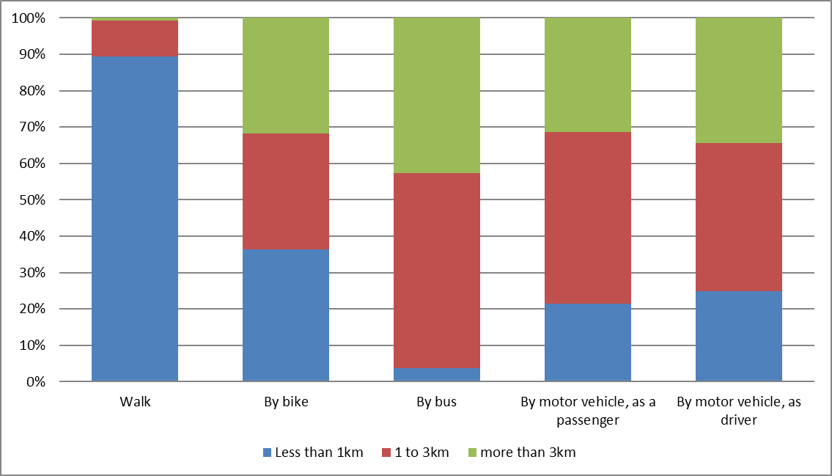
By combining estimates of how rail users access the station with daily boardings we have estimated number of people accessing the station by car who live within the 1 km catchment, see Table 11.

Table 11: Rail passengers within <1km catchment who access the station by car

The main findings from this analysis are as follows:
- Awarua and Khandallah have the highest proportions of people accessing the station on foot
- Raroa and Ngaio stations have the highest proportion accessing the station by motor vehicle (on average 42%) – these stations have 45 & 49 Park & Ride spaces each
- Approximately 29% of those driving to Raroa and 22% driving to Ngaio Station live within 1 km of station
- A low proportion of people are accessing the remaining stations by car

Figure 9 shows the home location and access mode to the station for survey participants. Of note is the overlap between car and walking access catchments.

Figure 9: 2017 and 2011 Rail survey access to station – northern Johnsonville line
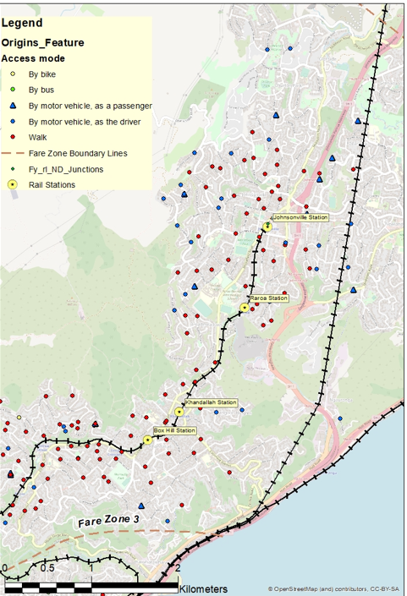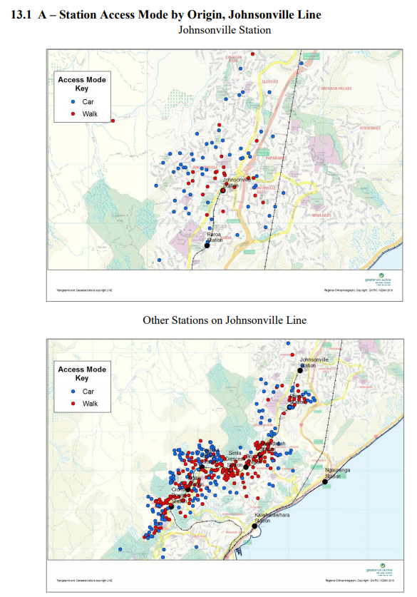

- Bus boardings
Bus boarding and alighting data is sourced from ETM ticketing (Metlink). It has been used as follows:
- to understand the number of boardings and alightings relating to trips to/from the CBD that occur within the 10-minute walking catchments of stations on the Johnsonville line
- to understand the level of overlap between bus and rail catchments
- estimate transfers from bus to rail (and vice versa) using combination of ETM data and survey data
Figure 10 shows average daily boardings to Wellington CBD during the month of November (2019) for stops within the 10-minute walk catchment of stations on the Johnsonville line.

Figure 10: Daily bus boardings within 10-minute walk catchment of stations on the Johnsonville line by ticket type
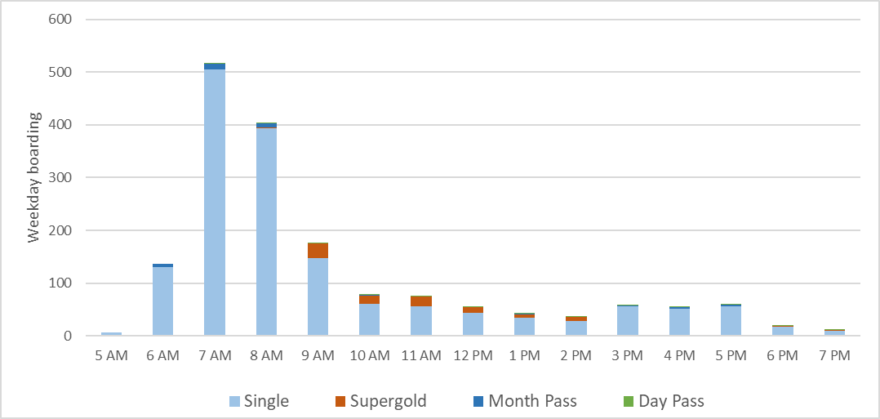
Figure 11 shows average daily alightings from services from Wellington CBD during the month of November (2019) for stops within the 10-minute walk catchment of stations on the Johnsonville line.
Figure 11: Daily bus alighting within 10 minute walk catchment areas by ticket type
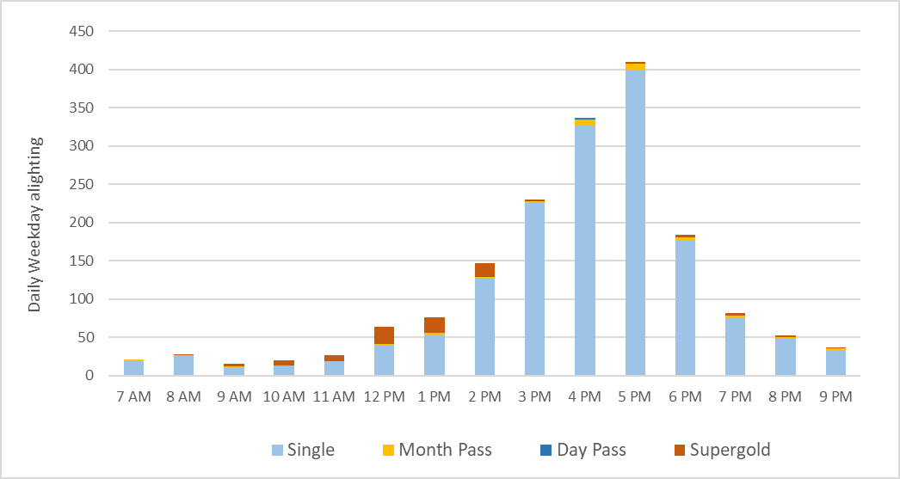
Table 12 shows weekly AM peak rail boardings (by station) and bus boardings within the 10-minute walk catchment areas of each station.
Table 12: Bus boarding and rail patronage
Station | Bus board to CBD within 10 min walk | Rail boarding AM peak | Ratio of bus to rail boardings
Johnsonville | 2976 | 995 | 25%
Raroa | 16 | 798 | 98%
Khandallah | 124 | 856 | 87%
Box Hill | 484 | 391 | 45%
Simla Crescent | 390 | 739 | 65%
Awarua Street | 275 | 647 | 70%
Ngaio | 321 | 819 | 72%
Crofton Downs | 3 | 831 | 100%
Total | 4,590 | 6,077 | 57%

The data shows the following:
- There are a high number of bus boardings to Wellington CBD within the 10-minute walk catchments for rail stations on the Johnsonville line, highlighting the fact the bus and rail are both convenient options for travelling to the CBD (particularly at peak times).
- Across the catchment area, bus and rail demand to the CBD in the AM peak is similar across bus and rail although it varies by station.
  - Within the Crofton Downs, Raroa and Khandallah catchments, most public transport users use the train to travel to the CBD.
  - Within the Box Hill, Simla Crescent, Ngaio and Awarua St catchments, around 35% of PT demand to the CBD is by bus and the remainder by rail
  - Within 10 min walk of Johnsonville station, 75% of people take the bus to the CBD compared to only 25% taking the train
- This analysis aligns with the Census journey to work data.
Figure 12.1: Bus boardings within 10-minute walk of Johnsonville line stations for AM peak

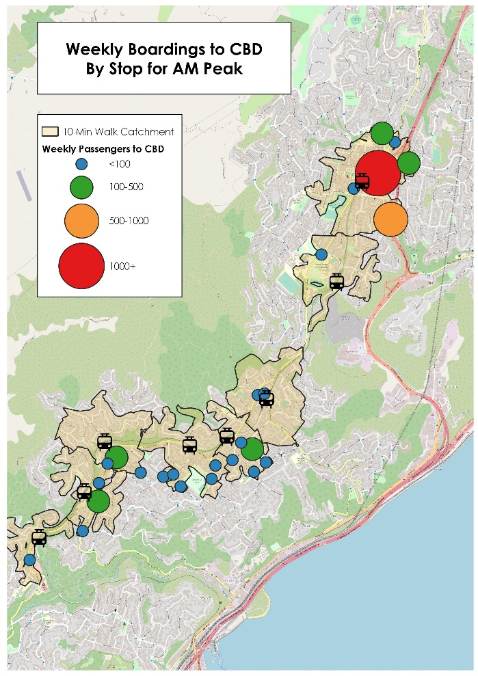

Note this is 20% down on pre-Covid
2011 Rail survey, Wellington Rail Report 2011-2012, GWRC. https://www.gw.govt.nz/regional-transport-analysis/
Rail Survey 2017: Park & Ride Data Note, GWRC; page 14. This analysis was based on the survey data, the number of people accessing the station by car was very low so any estimates should be treated with caution. As well, patrons who drove did not always access their closest station.

